THEORY QUESTIONS
1.
(a)

In an examination, 50 candiates sat for either Mathematics or English Language.
60% passed in Mathematics and 48% passed in English Language. If each candiate passed in at least one of the subjects, how many candidates passed in:
(i)

Mathematics?
(ii)

English Language?
(b)

Illustrate the information given in (a) on a Venn diagram.
(c)

Using the Venn diagram, find the number of candidates who passed in:
(i)

both subjects;
(ii)

Mathematics only.
(d)

If a =
(
4
-5
)
and b =
(
2x
3+y
)
are equal vectors, find the values of x and y.

2.
(a)

The cost (P), in Ghana cedis, of producing n items is given by the formula,
P =
3
4
n + 1800.
Find the:
(i)

cost of producing 2,000 items;
(ii)

number of items that will be produced with GH₵2,400.00;
(iii)

cost when no items are produced.
(b)

A passenger travelling by air is allowed a maximum of 20 kg luggage. A man has four bags weighing 3.5 kg, 15 kg, 2 kg and 1.5 kg.
(i)

Find the excess weight of his luggage.
(ii)

Express the excess weight as a percentage of the maximum weight allowed.

3.
(a)

A doctor treated 2,000 patients over a period of time. If he worked for 5 hours a day and spend 15 minutes on each patient, how many days did the doctor spend to treat all the patients?
(b)

The pie chart shows the distribution of textbooks to six classes A,B,C,D,E and F in a school.
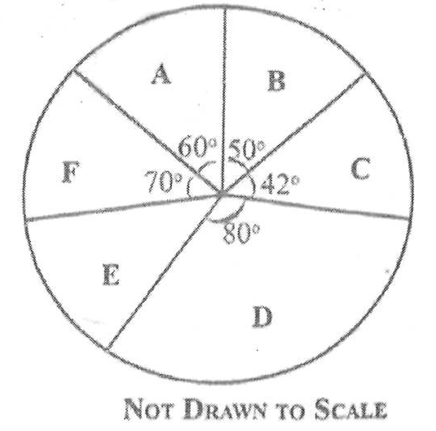
(i)

If class D was given 720 textbooks, how many textbooks were distributed to each of the remaining classes?
(ii)

What is the average number of textbooks distributed to the classes?
(iii)

How many classes had less than the average number of textbooks distributed?

4.
(a)

Using a scale of 2 cm to 1 unit on both axes, draw on a graph sheet two perpendicular axes 0x and 0y for -5 ≤ x ≤ 5 and -5 ≤ y ≤ 5.
(i)

Plot, indicating the coordinates of all points P(1,1), Q(1,2),R(2,2) and S(2,1) on the graph sheet. Join the points to form square PQRS.
(ii)

Draw and indicate clearly all coordinates, the image P₁Q₁R₁S₁ of square PQRS under an enlargement from the origin with a scale factor of 2, where P → P₁,Q → Q₁, R → R₁ and S → S₁.
(iii)

Draw and indicate clearly all coordinates, the image P₂Q₂R₂S₂ of square P₁Q₁R₁S₁ under a reflection in the x-axis where P₁ → P₂,Q₁ → Q₂, R₁ → R₂ and S₁ → S₂.
(b)

Using the graph in (a), find the gradient of line R₂S.

5.
(a)

Given that u = 4, t = 5, a = 10 and s = ut +
1
2
at², find the value of s.
(b)

The selling price of a gas cooker is GH₵450.00. If a customer is allowed a discount of 20%, calculate the:
(i)

discount;
(ii)

amount paid by the customer.
(c)

A crate of minerals containing ten bottles of Coca Cola and fourteen bottles of Fanta was given to some children for a birthday party. If a child chose a drink at random from the crate, find the probability that it was Fanta.

6.
(a)

Using a ruler and a pair of compasses only, construct:
(i)

triangle XYZ with |XY| = 9 cm,
|YZ| = 12 cm and |XZ| = 8 cm.
(ii)

the perpendicular bisector of line XY.
(iii)

the perpendicular bisector of line XZ.
(b)

(i)

Label the point of intersection of the two bisectors as T;
(ii)

With point T as center, draw a circle of radius 6 cm.
(c)

Measure:
(i)

|TX|;
(ii)

angle XYZ.

